TOP–DOWN PARSING
_____________________________________________________________________________________
It is an attempt to find a leftmost derivation of a string (expanding the leftmost non-terminal at every step).
Prior to top-down parsing, left-recursion must be compulsorily removed .
Left-factoring should be done, as it helps remove removable ambiguity.

Left-factoring
“Left factoring is a grammar transformation that is useful for producing a grammar suitable for predictive parsing. The basic idea is that when it is not clear which of two alternative productions to use to expand a non-terminal A, we may be able to rewrite the A-productions to defer the decision until we have seen enough of the input to make the right choice.”
- Aho,Ullman,Sethi
Here is a grammar rule that is ambiguous:
A -> xP1 | xP2 | xP3 | xP4 ….| xPn
Where x & Pi’s are strings of terminals and non-terminals and x !=e
If we rewrite it as
A->xP’
P’ -> P1|P2|P3 …|Pn
We call that the grammar has been “left-factored”, and the apparent ambiguity has been removed. Repeating this for every rule left-factors a grammar completely.
Example:
stmt -> if exp then stmt endif |
if exp then stmt endif else stmt endif
We can left factor it as follows :
stmt -> if exp then stmt endif ELSEFUNC
ELSEFUNC -> else stmt endif | e (epsilon)
Thereby removing the ambiguity

Recursive Descent Parsing
It is the most general form of top-down parsing. It may involve backtracking, that is making repeated scans of input, to obtain the correct expansion of the leftmost non-terminal. Unless the grammar is ambiguous or left-recursive, it finds a suitable parse tree
But, recursive-descent parsers are not very common as programming language constructs can be parsed without resorting to backtracking.
Example:
Consider the grammar:
S -> cAd | bd
A -> ab | a
and the string “cad”, parsed using Recursive-Descent Parser.
Step 1: Following the first rule, S->cAd to parse S
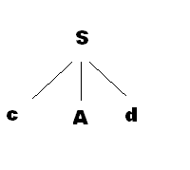
Step 2:The next non=term in line A is parsed using first rule, A -> ab , but turns out INCORRECT, parser backtracks
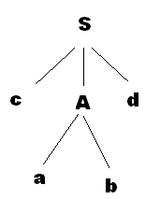
Step 3:Next rule to parse A is taken A->a, turns out CORRECT. String parsed completely, parser stops.
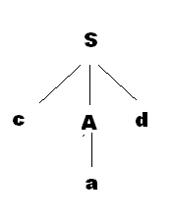
________
A left-recursive grammar can cause a recursive-descent parser, even the one with backtracking to go into an infinite loop. An attempt o expand A, we may find ourselves expanding A, without having consumed any input.
__________________________--

Predictive parser
It is a top-down parser that needs no backtracking.
At each step, the choice of rule to be expanded is made upon the made upon the next terminal symbol.
Suppose
A -> A1 | A2 | ….| An
If the non-terminal to be expanded next is ‘A’ , then the choice of rule is made on the basis of the current input symbol ‘a’ only.
Procedure for making an Predictive Parser:
- Make a transition diagram (like dfa/nfa) for every rule of the grammar.
- Optimize the dfa by reducing the number of states, yielding the final transition diagram.
- To parse a string, simulate the string on the transition diagram.
- If after consuming the input the transition diagram reaches an accept state, it is parsed.

Each of these steps are expanded below:
Consider the following grammar:
- E -> E + T | T
- T - > T * F | F
- F -> (E) | id
After removing left-recursion , left-factoring
The rules are as follows :
- E->T T’
- T’ -> +T T’ | e
- T -> F T’’
- T’’ -> *F T’’ | e
- F->(E) |id

Step 1: make dfa-like transition diagrams for each rule:
- E->T T’
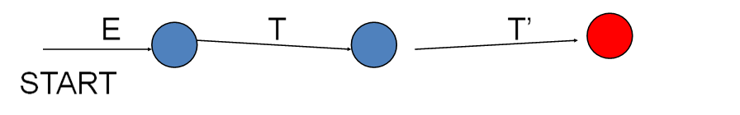
- T’ -> +T T’ | e
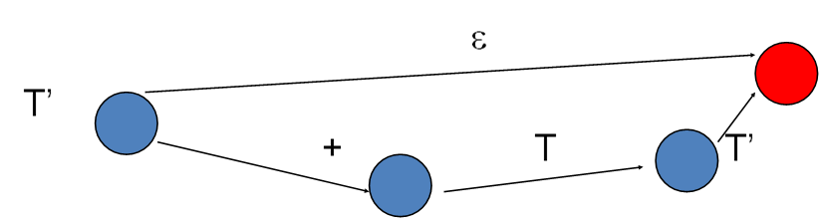

- T -> F T’’
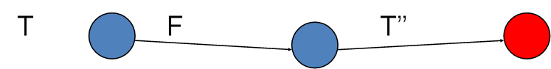

- T’’ -> *F T’’ | e
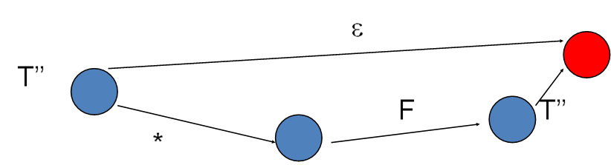

- F -> (E) |id
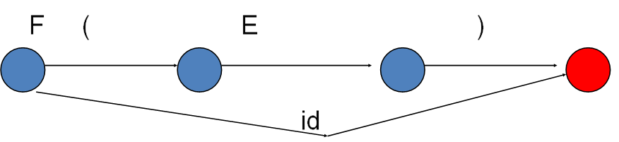

Step 2 : Optimization
The purpose of optimization is to reduce the number of states
Let’s optimize the states. Consider the dfa for T’ -> +T T’ | e shown below :

It can be optimized to

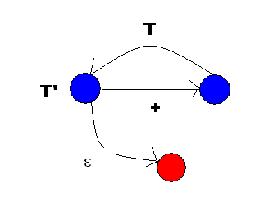
Which can be optimized further by combining with dfa for E->T T’ shown below
It yields
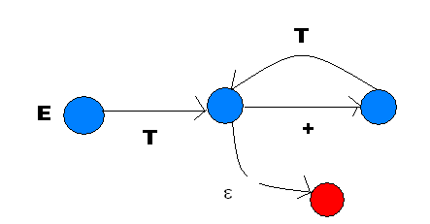
We can even further optimize it to produce
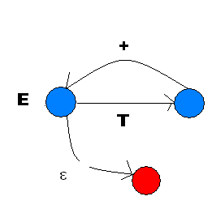
Similarly, we optimize other structures to produce the following dfa’s:
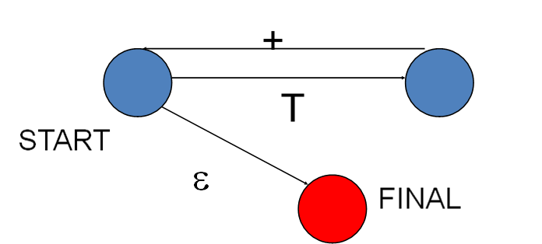
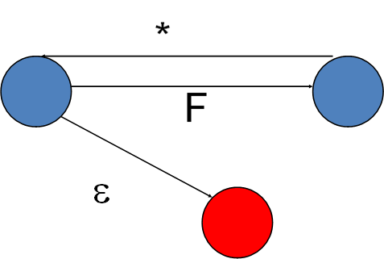
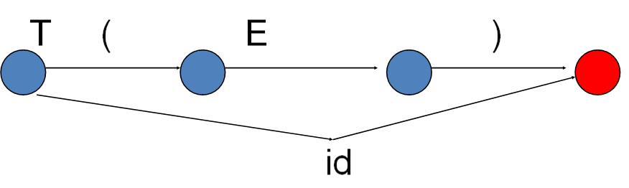

After optimization is over we start simulation over these “dfa’s”.

Step 3: Simulation on the input string:
Following steps list out the simulation procedure briefly.
- Start from the start state
- If a terminal comes consume it, move to next state
- If a non – terminal comes go to the state of the “dfa” of the non-term and return on reaching the final state
- Return to the original “dfa” and continue parsing
- If on completion( reading input string completely), you reach a final state, string is successfully parsed.

Disadvantages of Predictive Parser:
- It is inherently a recursive parser, so it consumes a lot of memory as the stack grows.
- Doing optimization may not be as simple as the complexity of grammar grows
- To remove this recursion, we use LL-parser, which uses a table for lookup.

