16.11.2006
G Shravan Kumar Reddy

DAG

Issues of optimization

- Breaking into basic blocks.
- Within block (Normalization optimization)
- Among blocks.

Things to consider for Normalization optimization

- Temporary variable minimization.
- Common sub-expression identification.
- Which are the basic variables that are used in basic block but come from outside.
- Which are the variables that have been updated in current basic block.

Using DAG to get the above information.

Example:
t1 = 4 * I
t2 = a [ t1]
t3=4 * I
t4 = b [ t3] ➔
t5 = t2 * t4
t6 = prod + t5
t7 = I + 1
I = t7
If I <= 20 goto 1

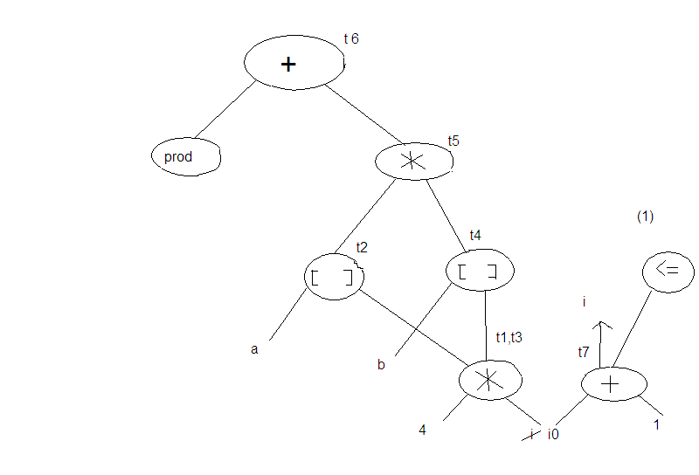

  - leaves are variables coming from outside.
  - Common sub-expressions are identified.
  - All variables appeared in node other than leaves are the variables updated here.
  - Additional info – equivalence of variables , which expressions are live can also be known.

Peep hole optimization

See small part of code at a time and fix easy “ BUGS ”

1) MOV R0 , a
MOV a , R0

2) goto L2

L2 : goto L3

- X = X + 0
X = X * 1

What we did not study :

- Optimization techniques
- Parallel compilers
- Lexical analysis , LL parser, SLR parser, Intermediate code generation , target code generation ( kidding).

