THREE ADDRESS CODE GENERATION

Consider the following grammar with its translation scheme for producing 3-address statements

S → id:= E S.Code := E.Code || gen(id.place ‘=’ E.place)
E → E + E E.place := newtemp( ) , E.Code =E₁.Code || E₂.Code || gen(E.place ‘=’ E₁.place + E₂.place)
E → E * E E.place = newtemp( ) , E.Code := E₁.Code || E₂.Code || gen(E.place ‘=’ E₁.place * E₂.place)
E → -E E.place = newtemp( ), E.Code := E₁.Code || gen (E.place ‘=’ ‘uni –‘ ‘E₁.place)
E → (E₁) E.place = E₁.place , E.Code = E₁.Code
E → id E.place = id.place , E.Code := ‘ ’

Consider the expression x := ( y + z ) * ( -w + v)

Annotated parse tree for the above expression will be :
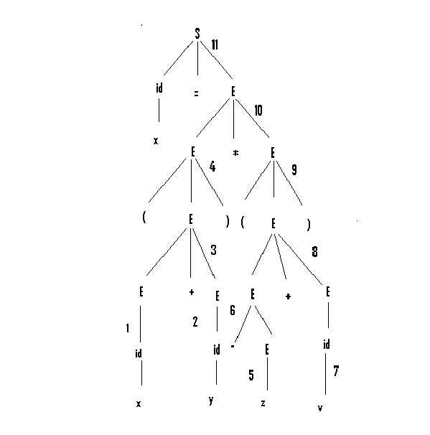

Three-address code statements for the above expression will be as follows:
- t1 = y +z
- t2 = -w
- t3 = t2 +v
- t4 = t1 * t3
- x = t4

Syntax directed translation for the above expression:

- E→id | E.place := y
- E→id | E.place := z
- E→E + E | E.place := t1 E.Code := gen( t1 = y + z )
- E→(E) | E.place := t1 E.Code := gen( t1 = y + z )
- E→id | E.place := w
- E→ -E | E.place := t2 E.Code := gen( t2 = -w)
- E→id | E.place := v
- E→E + E | E.place := t3 E.Code := gen( t2 = -w , t3 = t2 +v )
- E →(E) | E.place := t3 E.Code := gen( t2 = -w , t3 = t2 + v )
- E→E * E | E.place = t4 E.Code := gen( t1= y + z , t2 = -w , t3 = t2 + v , t4 = t1 * t3)
- S→id:=E | S.Code := gen(t1= y + z , t2 = -w , t3 = t2 + v , t4 = t1 * t3 , x=t4)

NOTES
    - S.code represents the three address code for assignment S
    - Non terminal E has 2 attributes
    - E.place, the name that will hold the value of E
    - E.code, the sequence of three-address statements evaluating E
    - The function newtemp returns a sequence of distinct names t1,t2 … in successive calls

ARRAYS:

1 Dimensional array
X[i] = A
A = X[i]
where X is the starting point and i is the offset from X.

Address of A[i] in terms of base address , low and high (generally low = 0)
=Base + ( i – low)*w (w= size of each address block in bytes)
= ( Base – low*w ) + i * w.

2 Dimensional array
A[ i , j ]
Address of A[i] in terms of base n₁ , n₂ , l₁ , l2
( l₁ , l₂ correspond to low of the two dimensions
n₁ , n2 correspond to the size of each array)
=Base + n₂ * w * ( i – l₁ ) + ( j – l₂ ) * w
= ( Base –( n₂*l₁ + l₂ )*w ) + w*(n₂*i + j)

-Prepared By-ARINDAM BARAL (04CS1034).

