LR(1) & LALR PARSER

By:
NITIN GOYAL 04CS1026
JITENDRA BINDAL 04CS1027

INTRODUCTION

The LALR ( Look Ahead-LR ) parsing technique is between SLR and Canonical LR, both in terms of power of parsing grammars and ease of implementation. This method is often used in practice because the tables obtained by it are considerably smaller than the Canonical LR tables, yet most common syntactic constructs of programming languages can be expressed conveniently by an LALR grammar. The same is almost true for SLR grammars, but there are a few constructs that can not be handled by SLR techniques.

CONSTRUCTING LALR PARSING TABLES

A core is a set of LR (0) (SLR) items for the grammar, and an LR (1) (Canonical LR) grammar may produce more than two sets of items with the same core.
The core does not contain any look ahead information.

Example: Let s1 and s2 are two states in a Canonical LR grammar.
S1 – {C ->c.C, c/d; C -> .cC, c/d; C -> .d, c/d}
S1 – {C ->c.C, $; C -> .cC, $; C -> .d, $}

These two states have the same core consisting of only the production rules without any look ahead information.

CONSTRUCTION IDEA:

- Construct the set of LR (1) items.
- Merge the sets with common core together as one set, if no conflict (shift-shift or shift-reduce) arises.
- If a conflict arises it implies that the grammar is not LALR.
- The parsing table is constructed from the collection of merged sets of items using the same algorithm for LR (1) parsing.

ALGORITHM:

Input: An augmented grammar G’.

Output: The LALR parsing table actions and goto for G’.

Method:

- Construct C= {I₀, I₁, I₂,…, In}, the collection of sets of LR(1) items.
- For each core present in among the set of LR(1) items , find all sets having the core, and replace these sets by their union.
- Parsing action table is constructed as for Canonical LR.
- The goto table is constructed by taking the union of all sets of items having the same core. If J is the union of one or more sets of LR (1) items, that is, J=I1 U I2 U … U Ik, then the cores of goto(I₁,X), goto(I₂,X),…, goto(I_{k}, X) are the same as all of them have same core. Let K be the union of all sets of items having same core as goto(I₁, X). Then goto(J,X)=K.

EXAMPLE

GRAMMAR:

- S’ -> S
- S -> CC
- C -> cC
- C -> d

SET OF ITEMS:
- I0 : S’ -> .S, $
S -> .CC, $
C -> .c C, c /d
C -> .d, c /d
- I1: S’ -> S., $
- I2: S -> C.C, $
C -> .Cc, $
C -> .d, $
- I3: C -> c. C, c /d
C -> .Cc, c /d
C -> .d, c /d
- I4: C -> d., c /d
- I5: S -> CC., $
- I6: C -> c.C, $
C -> .cC, $
C -> .d, $
- I7: C -> d., $
- I8: C -> cC., c /d
- I9: C -> cC., $
The goto graph:
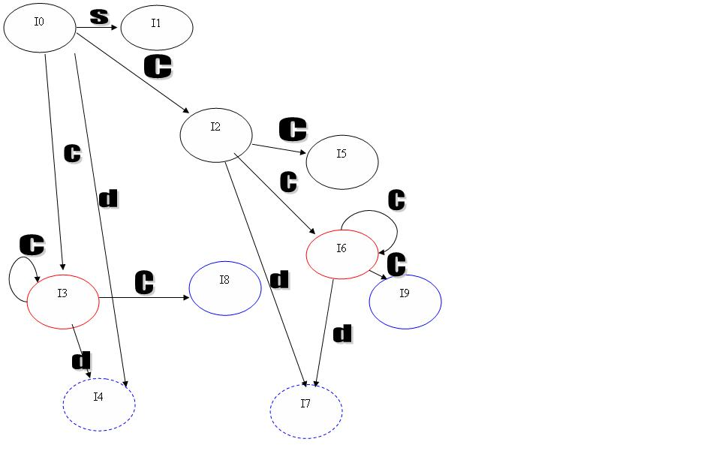

CANONICAL PARSING TABLE

STATE | Actions |  |  | Goto
STATE | c | d | $ | S | C
0 | S3 | S4 |  | 1 | 2
1 |  |  | acc
2 | S6 | S7 |  |  | 5
3 | S3 | S4 |  |  | 8
4 | R4 | R4
5 |  |  | R2
6 | S6 | S7 |  |  | 9
7 |  |  | R4
8 | R3 | R3
9 |  |  | R3

LALR PARSER

Merge the Cores:
3 & 6
4 & 7
8 & 9

LALR PARSING TABLE:

START | ACTION |  |  | GOTO
START | c | d | $ | S | C
0 | S36 | S47 |  | 1 | 2
1 |  |  | Acc
2 | S36 | S47 |  |  | 5
36 | S36 | S47 |  |  | 89
47 | R47 | R47 | R47
5 |  |  | R2
89 | R36 | R36 | R36

SHIFT-REDUCE CONFLICT

COMPARISON OF LR (1) AND LALR:

- If LR (1) has shift-reduce conflict then LALR will also have it.
- If LR (1) does not have shift-reduce conflict LALR will also not have it.
- Any shift-reduce conflict which can be removed by LR (1) can also be removed by LALR.
- For cases where there are no common cores SLR and LALR produce same parsing tables.

LR(1) Parser-
How Does a shift-Reduce conflict arises?

I_{A} : { E->α..βc, F->γ. }
& FOLLOW(F)={β}

For Eg. I₃ : {E->L.=R , R-> L. }
& Follow(E)={=}

For Solving this Problem by LALR Parser:
I_{A}={E->α.βc,ω₁ ; F->γ.,δ₁}
I_{B}={E->α.βc,ω₂ ; F->γ.,δ₂}
I_{AB}={E->α.βc,ω₁|ω₂ ; F->γ.,δ₁|δ₂}

COMPARISON OF SLR AND LALR:

- If SLR has shift-reduce conflict then LALR may or may not remove it.
- SLR and LALR tables for a grammar always have same number of states.

Hence, LALR parsing is the most suitable for parsing general programming languages.The table size is quite small as compared to LR (1) , and by carefully designing the grammar it can be made free of conflicts. For example, in a language like Pascal LALR table will have few hundred states, but a Canonical LR will have thousands of states. So it is more convenient to use an LALR parsing.

Eg.
S’->S
S->Bbb|aab|bBa
B->a

Set Of Items:
I₀:{S’->.S, S->.Bbb, S->.aab, S->.bBa, B->.a}
I₁:{S’->S.}
I₂:{S->B.bb}
I₃:{S->a.ab, B->a.} ←------------shift reduce conflict arises here
I₄:{S->b.Ba, B->.a}
I₅:{S->Bb.b}
I₆:{S->aa.b}
I₇:{S->bB.a}
I₈:{B->a.}
I₉:{S->Bbb.}
I₁₀:{S->aab.}
I₁₁:{S->bBa.}

LR(1) Parser:

I₀:{S’->.S,$; S->.Bbb,$; S->.aab,$; S->.bBa,$; B->.a,b }
I₁:{S’->S.,$}
I₂:{S->B.bb,$}
I₃:{S->a.ab,$; B->a.,b} ←---------------S-R conflict resolved here
I₄:{S->b.Ba,$; B->.a,a}
I₅:{S->Bb.b,$}
I₆:{S->aa.b,$}
I₇:{S->bB.a,$}
I₈:{B->a.,a}
I₉:{S->Bbb.,$}
I₁₀:{S->aab.,$}
I₁₁:{S->bBa.,$}

--------------------------------------------------------------------------------------------

REDUCE-REDUCE CONFLICT

However, the Reduce-Reduce conflicts still might just remain .This claim may be better comprehended if we take the example of the following grammar:

I_{A}={ A->γ₁.,δ_{1 ;} ->γ₂.,δ₂}

If δ₁≠δ₂ then NO reduce-reduce conflict.(mutual exclusive sets)

I_{A}={ A->γ₁.,δ_{1 ;} ->γ₂.,δ₂}
I_{B}={ A->γ₁.,δ₃ ; B->γ₂.,δ₄}
I_{AB}={ A->γ₁.,δ₁|δ₃ ; B->γ₂.,δ₂|δ₄}

Conflicts arises when δ₁=δ₄ or δ₂=δ_{3.}

S'-> S
S -> aAd
S -> bBd
S -> aBe
S -> bAe
A -> c
B -> c

Generating the LR (1) items for the above grammar,

I0 : S’-> .S , $
S-> . aAd, $
S-> . bBd, $
S-> . aBe, $
S-> . bAe, $
I1: S’-> S ., $
I2: S-> a . Ad, $
S-> a . Be, $
A-> .c, d
B->.c, e
I3: S-> b . Bd, $
S-> b . Ae, $
A->.c, e
B->.c,d
I4: S->aA.d, $
I5: S-> aB.e,$
I6: A->c. , d
B->c. , e
I7: S->bB.d, $
I8: S->bA.e, $
I9: B->c. ,d
A->c. , e
I10: S->aAd. , $
I11: S->aBe., $
I12: S->bBd., $
I13: S->aBe., $

The underlined items are of our interest. We see that when we make the Parsing table for LR (1), we will get something like this…

The LR (1) Parsing Table. (partly filled)

 | a ……………… | d | e
I₁  I₂  .  .  . |  | .  .  .  . | .  .  .  .
I₆ | ………………. | r6 | r7
..  .  . |  | .  .  .  . | .  .  .  .
I₉ | …………………. | r7 | r6
.

This table on reduction to the LALR parsing table, comes up in the forms of-

The LALR Parsing table. ( partly filled)

 | a ……………… | d | e
I₁  I₂  .  .  . |  | .  .  .  . | .  .  .  .
I₆₉ | ………………. | r6/r7 | r7/r6
..  .  . |  | .  .  .  . | .  .  .  .
I₉ | …………………. | r7 | r6
.

So, we find that the LALR gains reduce-reduce conflict whereas the corresponding LR (1) counterpart was void of it. This is a proof enough that LALR is less potent than LR (1).
But, since we have already proved that the LALR is void of shift-reduce conflicts (given that the corresponding LR(1) is devoid of the same), whereas SLR (or LR (0)) is not necessarily void of shift-reduce conflict, the LALR grammar is more potent than the SLR grammar.

SHIFT-REDUCE CONFLICT present in SLR

⇓ Some of them are solved in….

LR (1)

⇓ All those solved are preserved in…

LALR

So, we have answered all the queries on LALR that we raised intuitively.

