INDIAN INSTITUTE OF TECHNOLOGY, KHARAGPUR

Date 13.09.2006 17.00 Time: 30 min. Full Marks 20 No. of Students: 58
Autumn Semester, 2006.Department: Computer Science and Engineering Sub. No: CS 43001
3rd Yr. B. Tech.(Hons.) Sub. Name: Compiler Construction
Name : −−−−−−−−−−−−−−−−−−−−−−−−− RollNo:−−−−−−−−−−−−−−−

Instructions : Answer all the questions. Answer only what is asked. Do rough work in separate sheet of paper.

1. Given the grammar S’ → S
S → aABe
A → Abc
A → b
B → d
Deduce the sets of items. (4)

Ans: I₀: S’ → .S I₃: A → A.bc I₉: A → Abc.
S → .aABe I₄: A → b.
A → .Abc I₁₀: S → aABe.
A → .b I₅: B → d.
B → .d
I₆: S → aA.Be
I₁: S’ → S. B → .d

I₂: S → a.ABe I₇: A → Ab.c
A → .Abc
A → .b I₈: S → aAB.e

2. Construct the NFA, using Thomson construction method, for the regular expression a(a|b)*ab
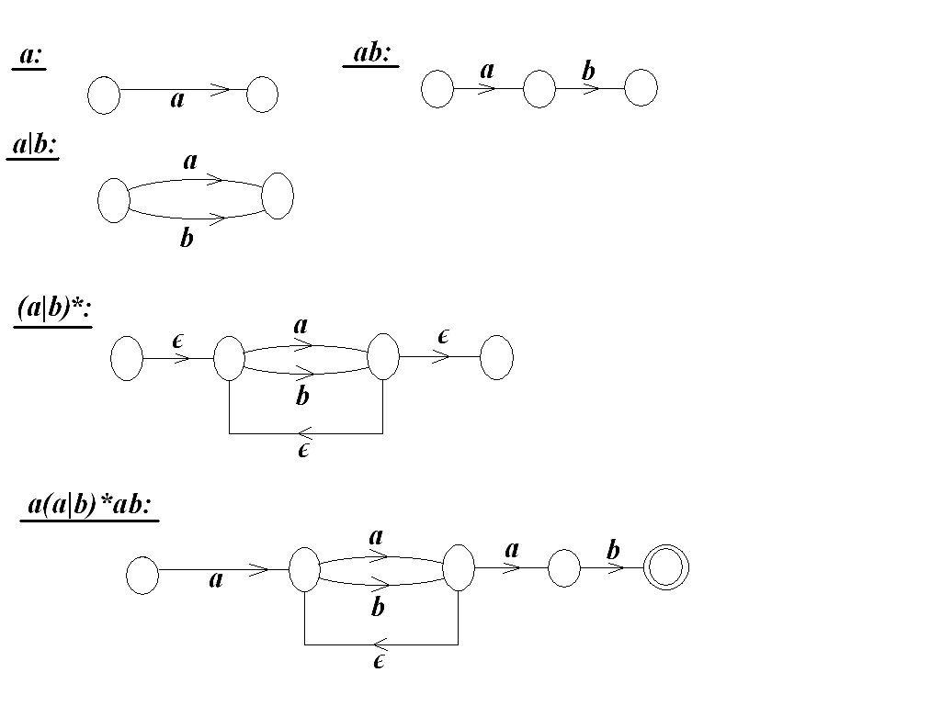
(5)
AA

3. Consider the grammar
E → E + E | E * E | id
develop the operator precedence table and show the steps subsequently executed to parse the string id * id + id. (5)

Ans:

Id + * $
Id > > >

+ < > < >

* < > > >

$ < < <

Stack Input Action
$ id * id + id $ shift
$id * id + id $ reduce E → id
$E * id + id $ shift
$E* + id $ shift
$E*id + id $ reduce E → id
$E*E + id $ reduce E → E*E
$E + id $ shift
$E+ id $ shift
$E+id $ reduce E → id
$E+E $ reduce E → E+E
$E $ accept

Operator Precedence Table

Configurations of shift-reduce parser on input id*id+id

4. Given the grammar
E → E + T | T
T → T * F | F
F → (E) | id
A. Eliminate left recursion from the grammar (2)

Ans: E → TE’
E’ → +TE’ | epsilon
T → FT’
T’ → *FT’ | epsilon
F → (E) | id

B. Derive optimized set of transition diagrams to implement recursive descent parsing for the above grammar. (4)
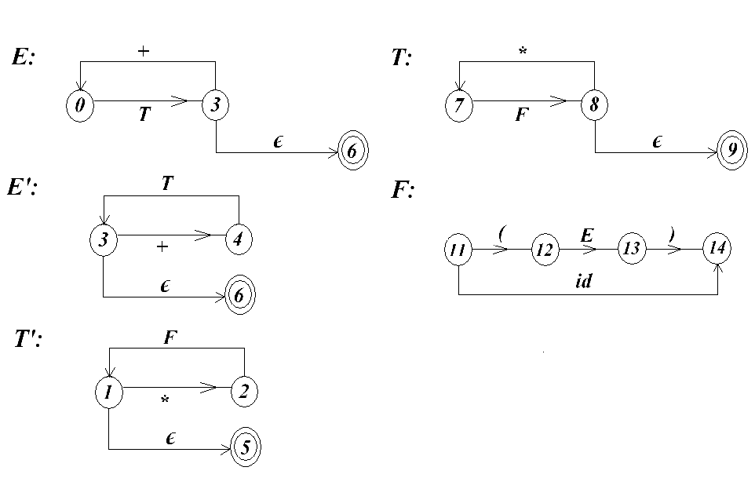
Ans:

