Question:

Let G be the following grammar: (04CS3006)
S-> S op1 S | S op2 S | A
A-> a | b
a. Prove that G is ambiguous.
b. Rewrite G to impose left associativity on both op1 and op2 and to impose higher precedence on op1 than op2. The resulting grammar should be unambiguous, and able to specify an LR(1) parser.

Ans: Grammer accepts a op1 a op2 b

2 possible trees:
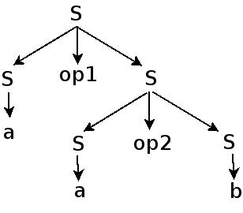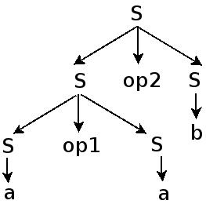
Hence the grammer is ambigious.

Revised Grammer

S -> A S | S1
A -> S1 op2
S1 -> B S1 | S2
B -> S2 op1
S2 -> a | b

LR(1) grammer

Adding a Starting production for the parser

S' -> S
S -> A S | S1
A -> S1 op2
S1 -> B S1 | S2
B -> S2 op1
S2 -> a | b

