CLASS TEST 2

Prepared By:: Rakesh Ranjan
04CS3024

Question number 1:
Identify the basic blocks and draw their flow graph:
- location = -1
- i=0
- if (i<100) goto 5
- goto 13
- t1 = 4*i
- go to 3
- t2 = A[t1]
- if t2 = x goto 10
- goto 11
- location = i
- t3 = i+1
- i = t3
- goto 3
- ..

Solution:
Leaders:
1, 3, 4, 5, 7, 9, 10, 11, 13

Basic blocks:
B1 = 1, 2
B2 = 3
B3 = 4
B4 = 5, 6,
B5 = 7, 8
B6 = 9
B7 = 10
B8=11, 12
B9 = 13

FLOW GRAPH::
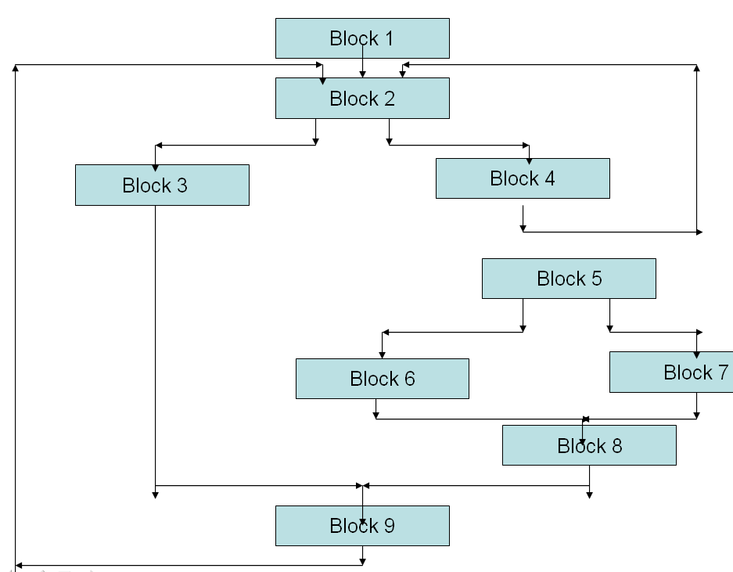

Question number 2::

Minimize the number of temporary variables in the given code

T1 = a * a
T2 = a * b
T3 = 2 * T2
T4 = T1 + T2
T5 = b * b
T6 = T1 + T2

Solution:

Here we can see that many variables are such that they are not live simultaneously.
we do can pack two temporaries into the same location if they are not live simultaneously

But if we change the sequence of our calculation we can do same calculation with only 1 variable also as it is calculating (a + b)^2 only

As given Below::

- T1 = a +b
- T1 = T1 * T1

- So we need only 1 temporary variable and with this we need one addition for calculating ( a+ b) and then by multiplying that by itself we get (a + b)^2.

Question number 3:

Write short circuit code for ((a<b )or (c<d) and (e<f))

Solution:
100: if a<b goto 103
101: t₁ := 0
102: goto 104
103: t₁ := 1
104: ifc<d goto 107
105: t₂ := 0
106: goto 108
107: t₂ := 1
108: if e<f goto 111
109: t₃ := 0
110: goto 112
111: t₃ := 1
112: t₄ := t₂ and t₃
113: t₅ := t₁ or t₄

Question 4)
For the given grammar draw the parse tree of the expression given below::

Grammar::

S -> if E then S
| if E then S else S
| while E do S
| begin L end
| A /*assignment*/
L -> L S
| S

Expression::

begin
while a > b do
begin
x = y + z
a = a - b
end
x = y - z
end

