Solutions to end-sem 2006-2007
1.
(a) t1 = a * b
t2 = c * d
t3 = t2 + a
t4 = t1 + t3
x = t4

(b) Consider the grammar

S´ -> S
S -> aA | aB
A -> b
B -> b

This will produce an LR(0) item { A -> b., B -> b.} and thus give rise to reduce-reduce conflict.

- i. elimination of common subexpression.
ii. identifying live variables (from previous block).
iii. identifying normal-form blocks.

- for i = 99 to 0 do
if a[i] = x then break
…….
end loop

(e)
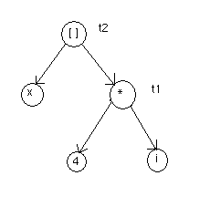
MOV R0,a
ADD R0,b
MOV b,R0

(g)

if condition

Statement 1

goto Statement.next
Statement 2

E.true

E.false

Statement.next

(h) PARAM x ₁
PARAM x ₂
.……………….
.……………….
PARAM x _{n}
Call P, n

- Static type checking saves the runtime overhead incurred during dynamic type checking.

(j) LALR: Lookahead Left to right scan Rightmost derivative
SLR : Simple Left to right scan Rightmost derivative
LR : Left to right scan Rightmost derivative
LL : Left to right scan Leftmost derivative

(k) Items in which the length of the lookahead strings are k are called LR(k) items.

(l) The input symbol depending upon which a parser decides its parsing action is called a lookahead.

(m) Two or more production rules with the same left-hand side and a common prefix in the right-hand side are said to have left-factoring.

(n) A macro is something which a pre-processor replaces by its value before compilation. Whereas an inline function is one which is coded inside the caller instead of being called but is done after compilation.

(o) A DAG merges common sub-expressions whereas in a Syntax Tree each subexpression has its own sub-tree.

(p) Analysis phase (Lexical analysis)
(Syntax analysis)
(Semantics analysis)
Synthesis phase (Intermediate code generation)
(Code optimization)
(Target code generation)

(q) A string of one or more a’s ending with a ‘b’.

(r) Lexical error
Syntax error
Semantic error
Logical error

2.
(a) S -> Aa | b
A -> Ac | Sd | ε

S -> Aa | b
A -> Ac | Aad | bd | ε

S -> Aa | b
A -> bdT | T
A -> cT | adT | ε

(b) E -> E + T { E.code = E₁.code || T₁.code || gen(‘+’) }
E -> E - T { E.code = E₁.code || T₁.code || gen(‘-’) }
E -> T { E.code = T.code}
T -> 0 { T.code = gen(‘0’) }
T -> 1 { T.code = gen(‘1’) }
.……………………………
T -> 9 { T.code = gen(‘9’) }

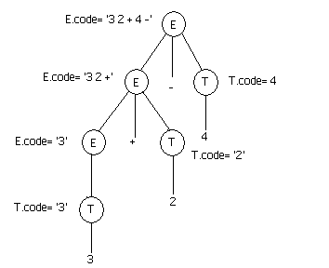

Annotated parse tree

(c) 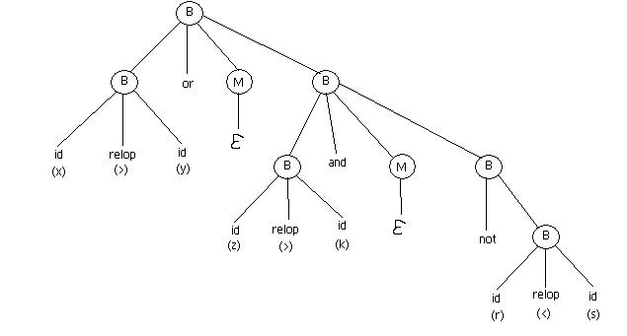

Parse Tree

Intermediate Code

0: if x > y goto
1: goto 2
2: if z > k goto 4
3: goto
4: if r > s goto
5: goto

B.truelist = { 0,5 }
B.truelist = { 3,4 }

3.
(a) t1 = c(X)
t2 = i * w(X)
t3 = Y + Z
t1[t2] = t3

(b) S -> L := E {
if (L.offset == NULL)
S.code = L.code || E.code || gen(L.place ‘=’ E.place)
else
S.code = L.code || E.code || gen(L.place’[‘L.offset’]’ ‘= ‘ E.place)
}
E > E + E {
E.place = newtemp()
E.code = E₁.code || E₂.code || gen(E.place ‘=’ E₁.place ‘+’ E₂.place)
}
E -> L {
if (L.offset == NULL)
{
E.place = L.place
E.code = NULL
}
else
{
E.place = newtemp()
E.code = gen(E.place ‘=’ L.place ‘[‘ L.offset ‘]’)
}
}
L -> id[E] {
L.place = newtemp()
L.offset = newtemp()
L.code = E.code || gen(L.place ‘=’ ‘c’ ‘(‘ id.place ‘)’) || gen(L.offset ‘=’ E.place ‘*’ ‘w’ ‘(‘ id.place ‘)’)
}
L -> id {
L.place = id.place
L.code = NULL
L.offset = NULL
}

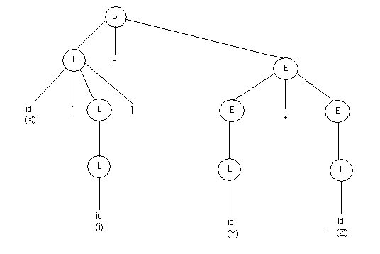
Parse Tree

Steps:

1. L.place = i
L.code = NULL
L.offset = NULL
2. E.place = i
E.code = NULL
3. L.place = t1
L.offset = t2
L.code = gen(‘t1 = c (X)’) || gen(‘t2 = i * w (X)’)
4. L.place = Y
L.code = NULL
L.offset = NULL
5. E.place = Y
E.code = NULL
6. L.place = Z
L.code = NULL
L.offset = NULL
7. E.place = Z
E.code = NULL
8. E.place = t3
E.code = gen(‘t3 = Y + Z’)
9. S.code = gen(‘t1 = c(X)’ || ‘t2 = i * w(X)’ || ‘t3 = Y + Z’ || ‘t1[t2] = t3’)
4.
(a) 0: sum = 0
1: term = 1
2: if term <= 100 goto 4
3: goto 9
4: t1 = sum + term
5: sum = t1
6: t2 = term + 1
7: term = t2
8: goto 2
9: ………..

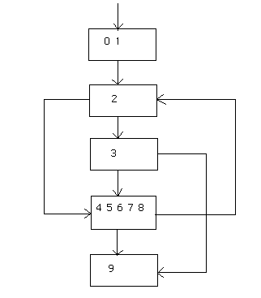
(Nos. in boxes indicate line nos.)
(b)
Intermediate code:
t1 = a – b
t2 = a – c
t3 = t1 + t2
t4 = a – c
t5 = t3 + t4
Statements | Code  generation | Reg  Descriptor | Addr  Descriptor | Comments
t1 = a – b | MOV a,R0  SUB b,R0  MOV R0,t1 | R0 has t1 | t1 in R0 | R0 < – a  R0 < – R0 – b  t1 < – R0
t2 = a – c | MOV a,R1  SUB c,R1  MOV R1,t2 | R0 has t1  R1 has t2 | t1 in R0  t2 in R1 | R1 < – a  R1 < – R1 – c  t2 < – R1
t3 = t1 + t2 | MOV t1,R1  ADD t2,R1  MOV R1,t3 | R0 has t1  R1 has t3 | t1 in R0  t3 in R1 | R1 < – t1  R1 < – R1 + t2  t3 < – R1
t4 = a – c | MOV a,R1  SUB c,R1  MOV R1,t4 | R0 has t1  R1 has t4 | t1 in R0  t4 in R1 | R1 < – a  R1 < – R1 – c  t4 < – R1
t5 = t3 + t4 | MOV t3,R1  ADD t4,R1  MOV R1,t5 | R0 has t1  R1 has t5 | t1 in R0  t5 in R1 | R1 < – t3  R1 < – R1 + t4  t5 < – R1

5.
(a) We replace ‘if’ by ‘i’ and ‘else’ by ‘e’

S´ –> S
S –> iSeS | iS | a

I₀: S´ –> . S I₃: S –> a .
S –> . iSeS
S –> . iS I₄: S –> iS . eS
S –> . a S –> iS .

I₁: S´ –> S . I₂: S –> iSe . S
S –> . iSeS
I₂: S –> i . SeS S –> . iS
S –> i . S S –> . a
S –> . iSeS
S –> . iS I₆: S –>iSeS .
S –> . a

LR(0) items
SLR parsing table

STATE | action |  |  |  | goto
STATE | i | e | a | $ | S
0 | S2 |  | S3 |  | 1
1 |  |  |  | acc
2 | S2 |  | S3 |  | 4
3 |  | R4 |  | R4
4 |  | S5 |  | R3
5 | S2 |  | S3 |  | 6
6 |  | R2 |  | R2

(Rules are numbered from1)
Here action[4][e] = S5/R3. According to question S5 is chosen.

(b) S´ –> S
S –> CC
C –> cC | d

I₀: S´ –> . S, $
S –> . CC, $
C –> . cC, c/d
C –> . d, c/d

I₁: S´ –> S . , $

I₂: S –> C . C, $
C –> . cC, $
C –> . d, $

I₃: C –> c . C, c/d
C –> . cC, c/d
C –> . d, c/d

I₄: C –> d . , c/d

I₅: S –> CC . , $

I₆: C –> c . C, $
C –> . cC, $
C –> . d, $

I₇: C –> d . , $

I₈: C –> cC . , c/d

I₉: C –> cC . , $

LR(1) items

Goto Table
 | c | d | $ | S | C
0 | 3 | 4 |  | 1 | 2
1
2 | 6 | 7 |  |  | 5
3 | 3 | 4 |  |  | 8
4
5
6 | 6 | 7 |  |  | 9
7
8
9

STATE | action |  |  | goto
STATE | c | D | $ | S | C
0 | S3 | S4 |  | 1 | 2
1 |  |  | Acc
2 | S6 | S7 |  |  | 5
3 | S3 | S4 |  |  | 8
4 | R4 | R4
5 |  |  | R2
6 | S6 | S7 |  |  | 9
7 |  |  | R4
8 | R3 | R3
9 |  |  | R3

LR(1) parsing table

(Rules are numbered from1)
LALR parsing table

STATE | action |  |  | goto
STATE | c | D | $ | S | C
0 | S36 | S47 |  | 1 | 2
1 |  |  | Acc
2 | S36 | S47 |  |  | 5
36 | S36 | S47 |  |  | 89
47 | R4 | R4 | R4
5 |  |  | R2
89 | R3 | R3 | R3

(Rules are numbered from1)

